Student: Leonardo Oliveira

Class: CMSC 203

Professor: Robert S. Alexander

STEP 1

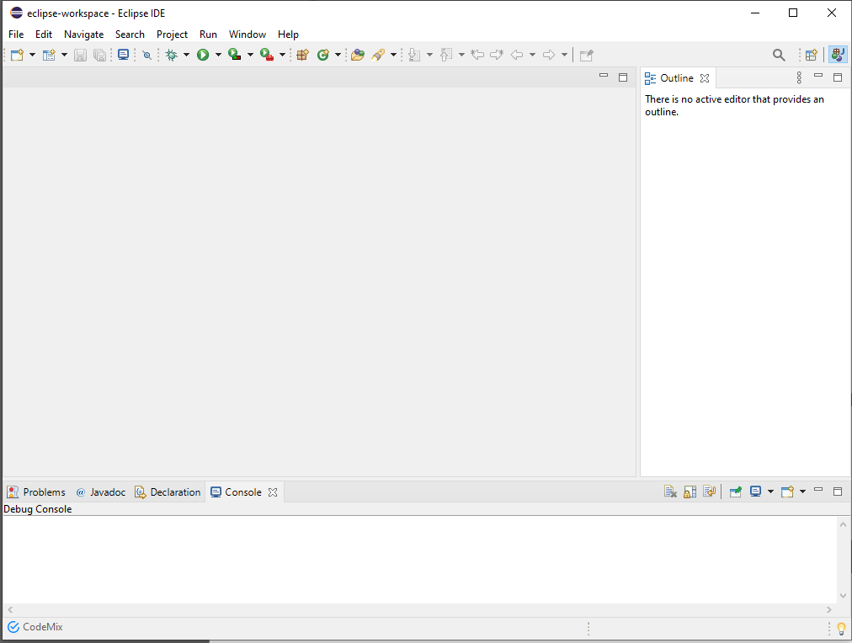

STEP 2

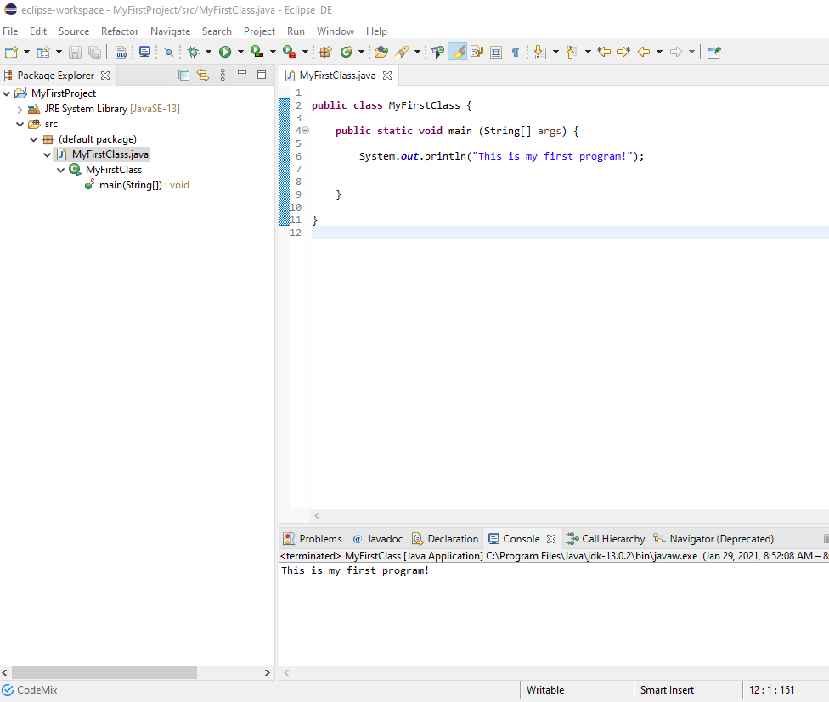

GIT HUB UPLOAD